## Platform classifications

1. Servers

These servers consist of **Access server** and **Main Trade Server**, **History Server**, **Backup Server**, etc.

These server components are main part for Forex trading.

These are interacting with several terminals and connect with financial market.

1. Terminals

These components consist of terminals for traders and terminals for administration.

* Administration terminals

These terminals include **Administrator** and **Manager** terminal.

Administrator terminal control the servers and configure the information of servers.

* Trader terminals

These terminals include **Client terminal** and **Web terminal, Mobile terminal**.

Traders can create trading accounts (real account and demo account) and open positions and track the symbol prices, etc.

1. MetaTrader 5 API

Using this API, the Traders can implement their trading strategies.

MetaTrader 5 Architecture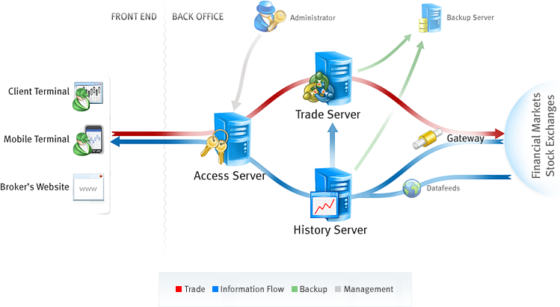

## Platform Components

The trading platform consists of the following components:

* Main Trade Server

Besides the tasks of maintaining trading, this sever is designed for managing the entire platform. It means that the administrator of the main trade server can control the entire system.

* Trade Servers

Besides the main trade server, the unlimited number of trade servers can be installed. They are intended for storing and managing all client and trade databases; trading activities are performed through them.

* Access Server

Access servers are proxy servers and firewalls of the system at the same time. They check clients' connections, collect authorization information and route clients' connections. Besides that access servers cache the largest part of all data transmitted to a client (including history data and terminal updates).

* History Server

History server receives, processes and stores price data, news and updates, and transmits them to other components of the system.

* Backup Server

Backup servers create backups of both history and trade servers.

* Data Feeds

Data feeds are special components of the platform that are implemented as separate executable files that enable the receipt of news and quotes from different providers.

* Gateways

Gateways are intended for integration of the MetaTrader 5 platform with ECNs and exchanges. Gateways allow bringing out trade operation to external systems as well as translating quotes and news from them.

* Administrator Terminal

This terminal enables the remote control of the entire MetaTrader 5 platform. It allows changing any platform settings, managing client and trade databases and perform other operation.

* Manager Terminal

This terminal is used for working with the broker's clients: managing databases, servicing trading operations, reporting and managing risks.

* Client Terminal for Windows

The trader's main workstation enabling traders to analyze quotes and to execute trading operations. It features algo trading and strategy testing facilities.

* Mobile Terminal for iOS

It enables traders to manage their trading accounts, to view symbol charts and to perform trading operations using iPhone or iPad.

* Mobile Terminal for Android

The terminal enables traders to manage their trading accounts, to view symbol charts and to perform trading operations using Android powered smartphones and tablets.

* WebTerminal

MetaTrader 5 WebTerminal allows trading in the financial markets via a web browser. It works in all operating systems and browsers requiring no additional software.

* MetaTrader 5 API

It is a toolkit which allow further expansion of the platform capabilities, integration with other trading systems and back-office components, as well as platform customization for specific business needs.

## Functions of Server components

### Trading server

The main trading server serves trading operations and manages the entire system configuration.

The trading server performs the following functions:

* Storing and management of clients' records.
* Authentication and authorization of client connections.
* Storing and management of trade records.
* Check, management and execution of trade requests.
* Management of the internal mailing system.

### Access Server

Access servers are proxy servers and the platform firewalls at the same time. They perform the following functions:

* Processing of incoming client connections.
* Packing authorization requests and sending them to the trade server.
* Checking activity of client connections protecting the trade server from attacks and overload
* Saving history data, depth of market and news, and translate them to clients, thus reducing the load to the history server.
* Monitoring the operation of the history and trade servers.

The unlimited number of access servers can exist for each trade server. Terminals are switched between them automatically, depending on the priority settings.

### History Server

The history server processes price and news data. This server performs the following functions:

* Receiving and filtering price and news data from gateways and datafeeds.
* Packing price and news data.
* Storing and providing price history in the form of 1-minute bars and ticks to other components of the platform.
* Storing and providing the news thread.

### Backup Server

Servers of this type are used for creating backup copies of data that will be used in case of the trade or history server failure. They perform the following functions:

* They provide the real-time backuping of the trade server and the history server. Each server is associated with one or more separate backup server instances which can replace it at any time.
* They create backups of all databases every day, besides they perform regular backups of client and trade bases.
* When backuping a history server they create real time backups of data required for correct restoring of gateways: custom settings that can be stored (at developer's discretion) in the settings.dat file in a gateway work folder, and trade executions database.
* They provide automatic failover in case the primary server becomes unavailable.
* Using backup servers, you can easily migrate servers to new hardware.
* Backup servers enable you to quickly restore server operation in the manual mode.
* Replicate information to database managed by MySQL, MariaDB, PostgreSQL, Firebird, MSSQL or Oracle.

### Gateways

Gateways are intended for integration of the MetaTrader 5 platform with external trade systems. Gateways allow bringing out trade operation to external systems as well as translating quotes and news from them. Gateways are executable files that run as separate processes.

### Data Feeds

Data feeds enable receipt of quotes and news in the online trading platform. They transmit information to the history server, from which they are translated to access points (data centers) and terminals. The trading platform includes several data feeds that enable receiving of quotes and news from the most popular feed providers

## Workflow of Platform

### Trade operation



All the requests of clients are translated to the liquidity provider (remote platform) via the trading platform. The response from the liquidity provider is transmitted to the client. The platform is configured in such a way that the clients' trade requests are sent to the gateway. The gateway checks the clients' requests and after the successful check creates new trade requests to a remote platform. After receiving a response from the remote platform, the gateway returns a response to the client's request to the trading platform.

* Client connects the platform in terms of various terminals such as client terminal, mobile or web
* Client’s trading requests are sent to the access server then the access server check the authentication and authorization of client’s connection.
* After successful authorization, access server translates the client’s request to the trade server.
* Trade server checks the validation of the client’s request and creates new order for the request then send it to gateway.
* The gateway brings out the trading operation to remote platform and receive the response from them.
* The gateway sends the response to the trade server, the server records the result and translate it to access server.
* Client can receive the result of trade from access server.

### Quote and History



Gateways also allow translating quotes and news from external platform. They transmit information to the history server, from which they are translated to access points (data centers) and terminals.

* Gateway receive quote information from external platform and translate them to the history server.
* History server record the price of quote and update them with the configuration of the trading platform. For example, for the markup of spread, it will be added the price at exchange.
* History server send the detail of quotes to the Trade server which uses the quotes to take trades of clients
* History server make the tick of symbol and 1-minute chart history base on the quotes and provides them to access server and trade server.
* Access server broadcasts the ticks and charts to the authorized clients.